HAP 780: FINAL PROJECT

TO FIND OUT HOW LONG THE PATIENT

ARE GOING TO STAY IN THE HOSPITAL

AFTER COMING OUT FROM ICU

**Professor: Hong Xue**

Namratha Alapati

Sanisha Kolanu

Shiny Manasseh Chilakabathini

**Abstract:**

This Project is focused on evaluating various classification algorithms within the Weka framework. Its goal was to predict the length of hospital stays after patients were discharged from the Intensive Care Unit (ICU), considering various medical conditions that could affect the duration. The methodology began with data preparation, where SQL Server Management Studio was utilized for processing and cleaning the data. This prepared data was then converted to CSV format, making it compatible for import into Weka, where it was used for in-depth analysis and the development of predictive models. The research involved creating several models to predict if a patient's hospital stay would surpass one week. This was achieved by using data from the MIMIC III database, a comprehensive source of clinical data. The focus of the study was not just to develop any predictive model, but rather to pinpoint the most accurate one that could reliably forecast prolonged hospital stays exceeding a week post-ICU discharge. The overall aim was to enhance the predictability of patient care outcomes, potentially leading to better resource management within the healthcare system.

**Introduction and background work:**

The research aims to address the critical need for predicting hospital length of stay (LOS), which serves as a vital metric for assessing the efficiency of patient care and overall hospital performance. The ability to forecast LOS enables healthcare facilities to proactively identify patients at risk of prolonged hospitalization. By doing so, treatment plans can be adjusted right from the point of admission to minimize the duration of the hospital stay. Efficient LOS prediction also empowers hospitals to better manage patient expectations regarding their stay, set during the admission process, and subsequently improve resource allocation.

Moreover, accurate LOS predictions enhance the hospital's capacity to manage ICU bed availability, particularly in the face of rising patient counts. While hospitals may not predict exact admission numbers in advance, once a patient is admitted, determining whether they require ICU care or general ward care is crucial. Understanding the potential duration of ICU stay is essential for effective bed management and staff utilization, minimizing the variance in bed occupancy rates.

The study also considers the various factors that influence LOS, including initial misdiagnoses, patient responses to treatments, and the level of nursing care provided, which may impact the length of hospitalization. Despite these complexities, the research proceeds with a robust dataset, acknowledging that in the United States, healthcare services account for a significant portion of the national budget. With an average LOS of 5-7 days and considerable costs per hospital stay, there's a clear incentive to optimize hospital stays, particularly for the elderly population, who are frequently hospitalized.

The project sets out to analyze the LOS for patients admitted to the ICU, considering the diverse medical scenarios they present with—ranging from multiple comorbidities to acute conditions resulting from accidents. The objective is to develop a predictive model that accurately gauges the duration of post-ICU hospitalization, thereby contributing to more efficient hospital operations and improved patient care outcomes.

**Dataset Description:**

For this research project, the MIMIC-III dataset has been employed as the foundation for predicting patients' hospital length of stay post-ICU discharge through data analysis and the application of machine learning models. The MIMIC-III dataset is a comprehensive relational database encompassing a wealth of patient data acquired during hospital stays following ICU care. It is well-structured, with tables interconnected through two primary identifiers: HADM_ID, which denotes unique hospital admissions, and SUBJECT_ID, which corresponds to individual patients.

This open-access dataset is rich with various types of clinical information, such as:

Laboratory measurements that provide data on various tests performed during a patient's stay.

Medications ordered, detailing the drugs prescribed throughout hospitalization.

Hospital assigned diagnosis, which includes the medical diagnoses assigned to patients.

Patient procedures that record the specific medical procedures undergone by the patients.

The datasets selected from MIMIC-III for analyzing ICU length of stay include:

ADMISSIONS: Contains details of each patient's hospital admissions, identified by HADM_ID, offering a timeline of hospital stays.

CPTEVENTS: Records medical procedures as CPT codes, indicating specific interventions performed.

DIAGNOSES-ICD: Includes diagnostic data for each patient, with corresponding ICD codes for these diagnoses.

ICU_STAYS: Provides information about each patient's stay in the ICU, identified by ICUSTAY_ID.

PATIENTS: Holds demographic and hospital-independent information about all patients, including gender and date of birth.

PROCEDURES_ICD: Lists all medical procedures experienced by patients, coded according to ICD standards.

This complex relationship illustrates the potential for patients to be admitted to one or multiple hospitals during their treatment trajectory, which is a significant consideration in analyzing and predicting ICU length of stay.

**Problem Statement:**

To develop a predictive model that accurately forecasts whether a patient's length of stay after Intensive Care Unit (ICU) treatment will exceed more than a week.

**Data Pre-Processing:**

We have used the Azure Data Studio as SQL server in order to process the data in way where it can support the data in WEKA. To start with I have used the Admissions table which has few factors that need to be converted for the data mining purpose in WEKA.

1. ADMISSIONS Table:

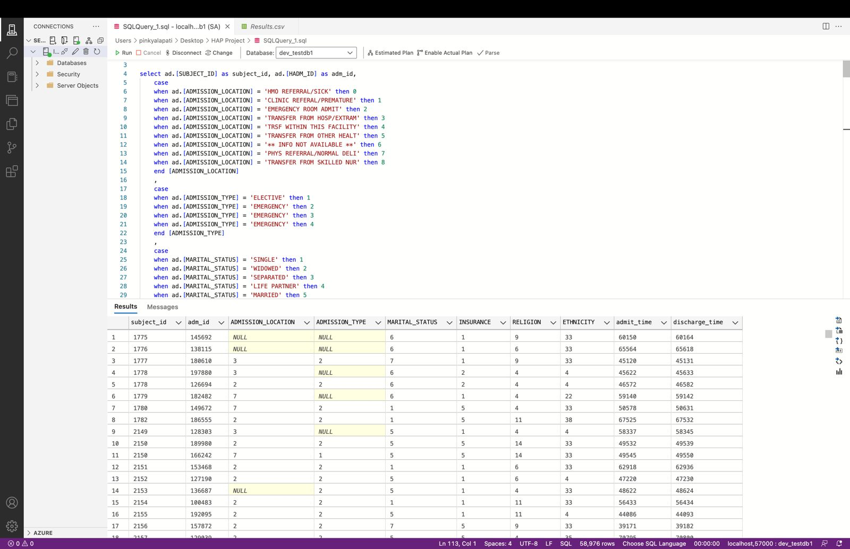

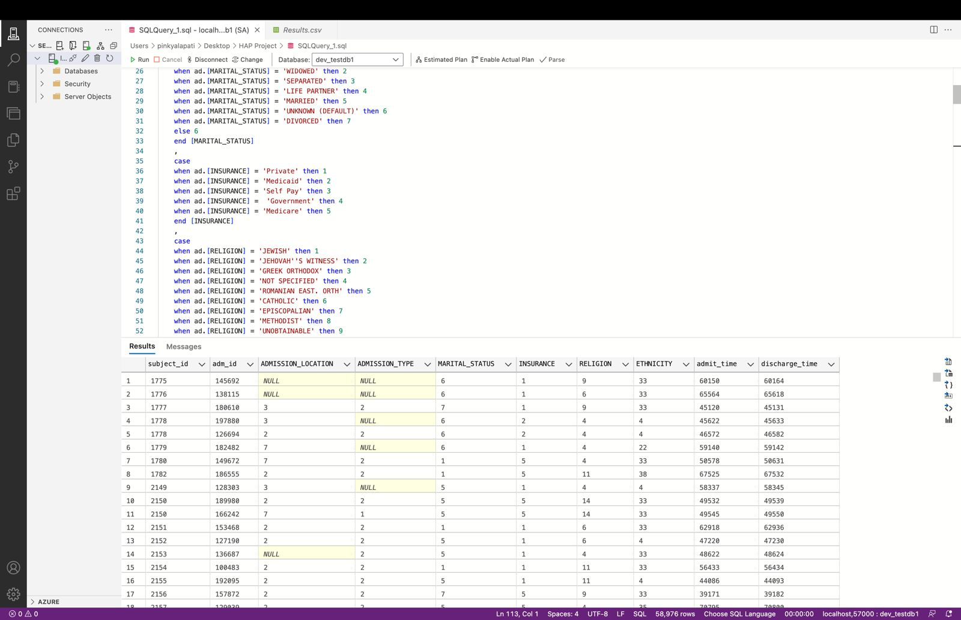

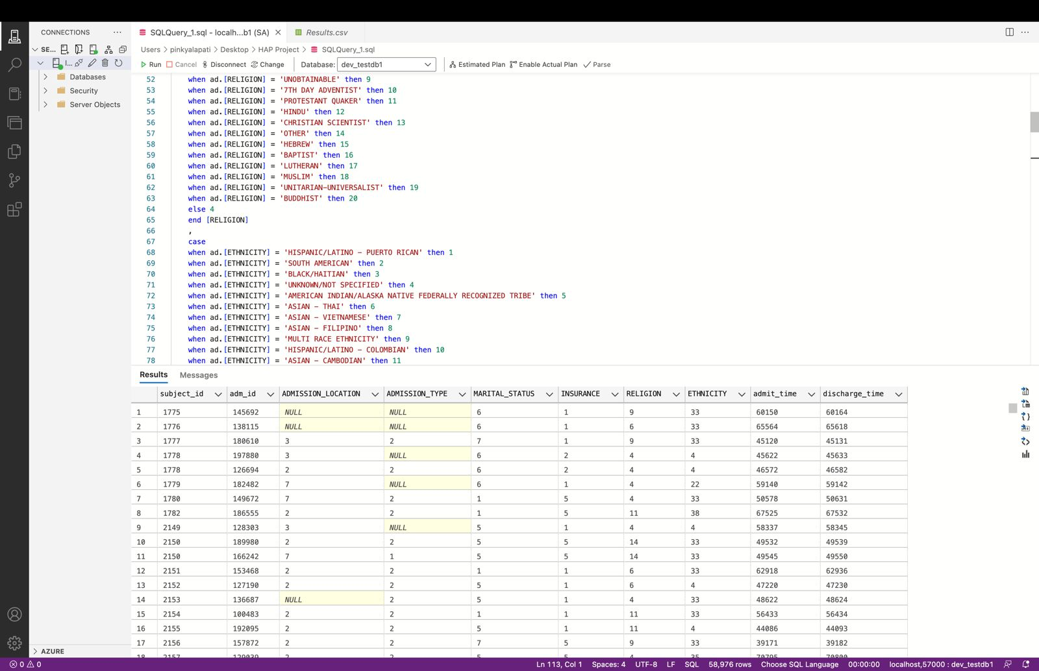

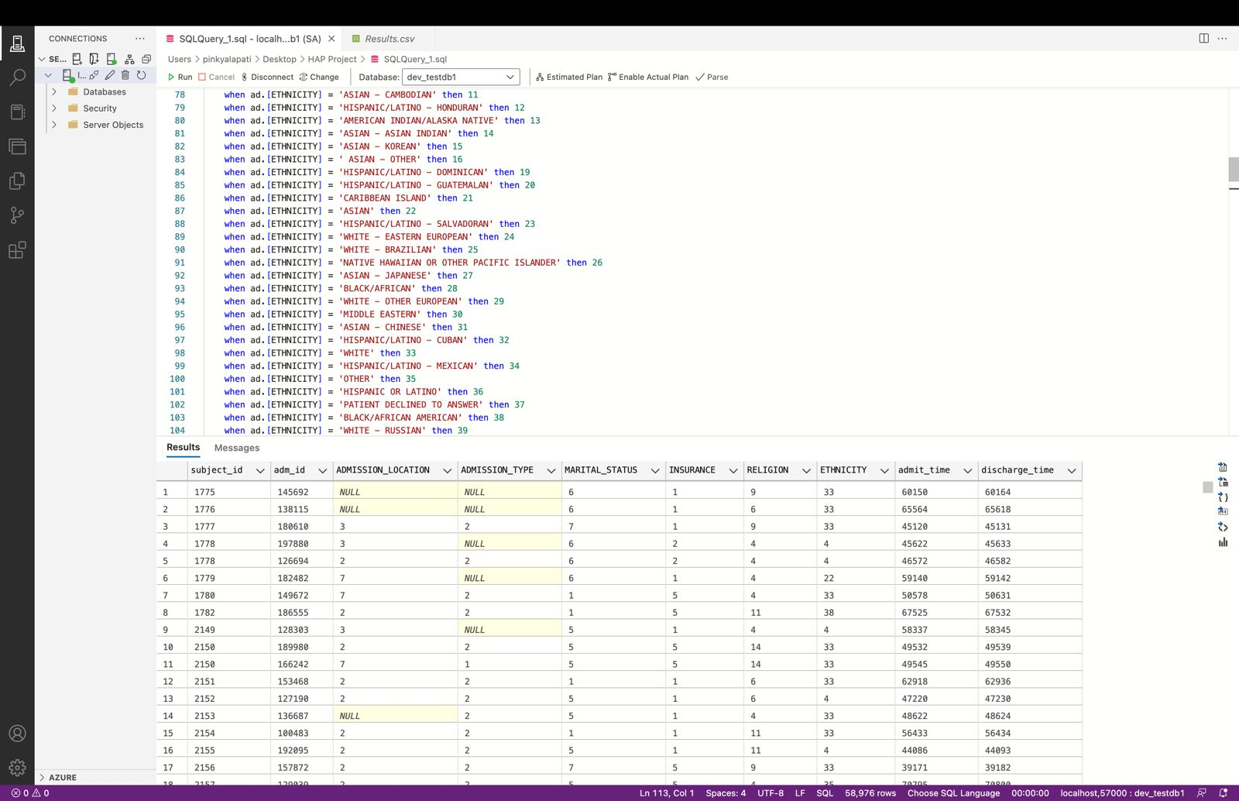

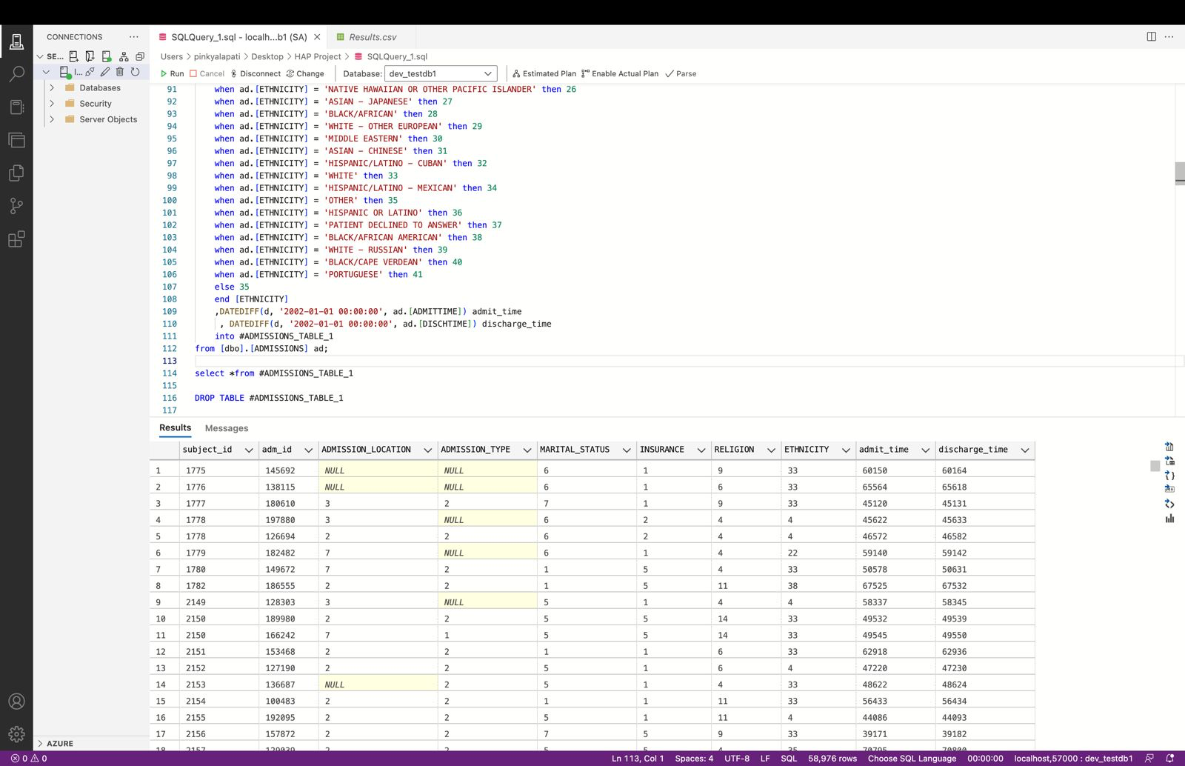

From above screenshots we can tell that we have converted all the data into numerical format. So, that it can support in the Weka for further analysis.

1. PATIENTS Table:

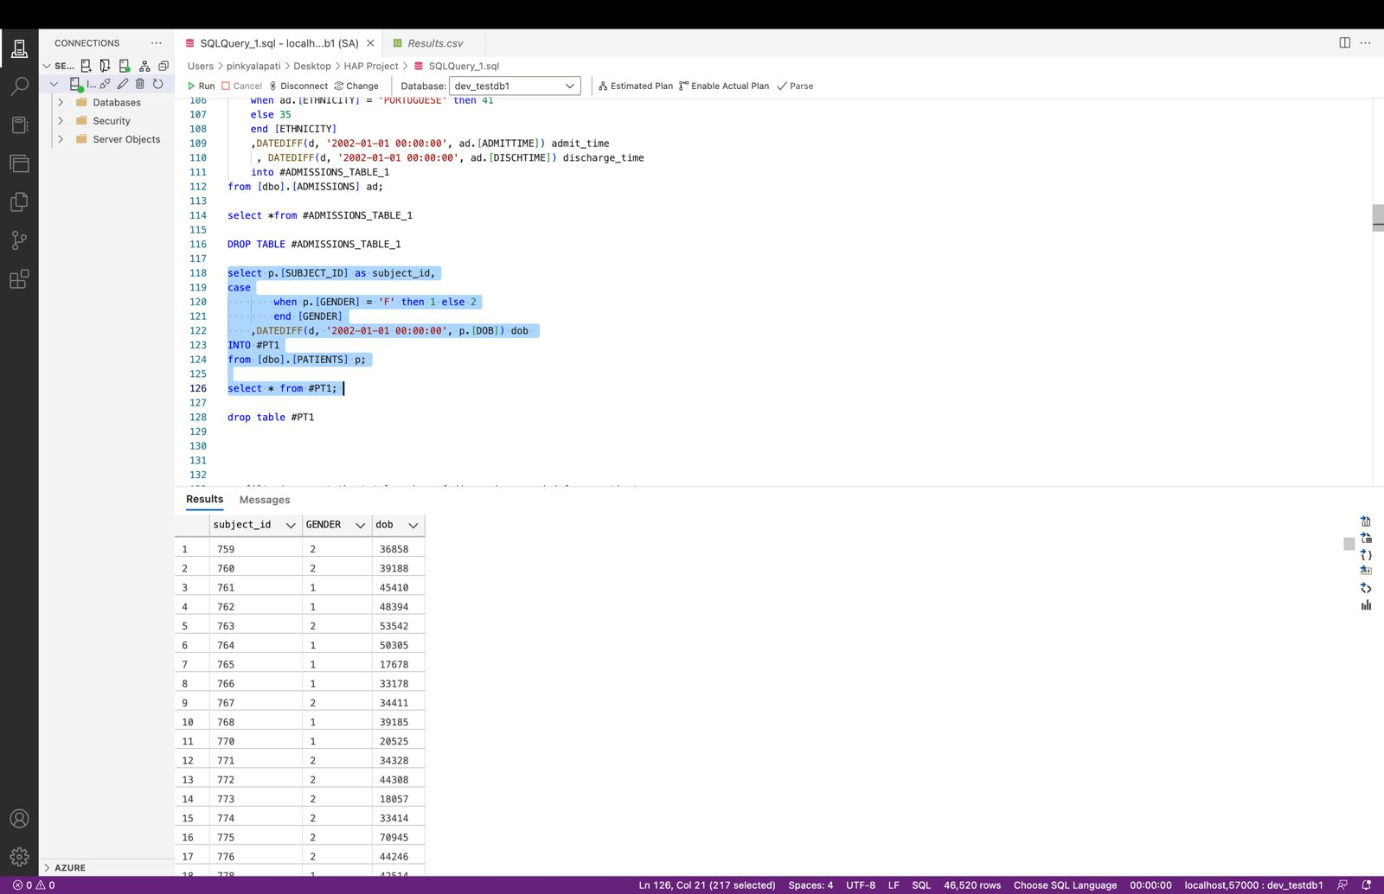

From the above screenshot we can tell that we have converted the Gender column into numeric values with Female as 1 and Male as 2.

1. DIAGNOSIS Table:

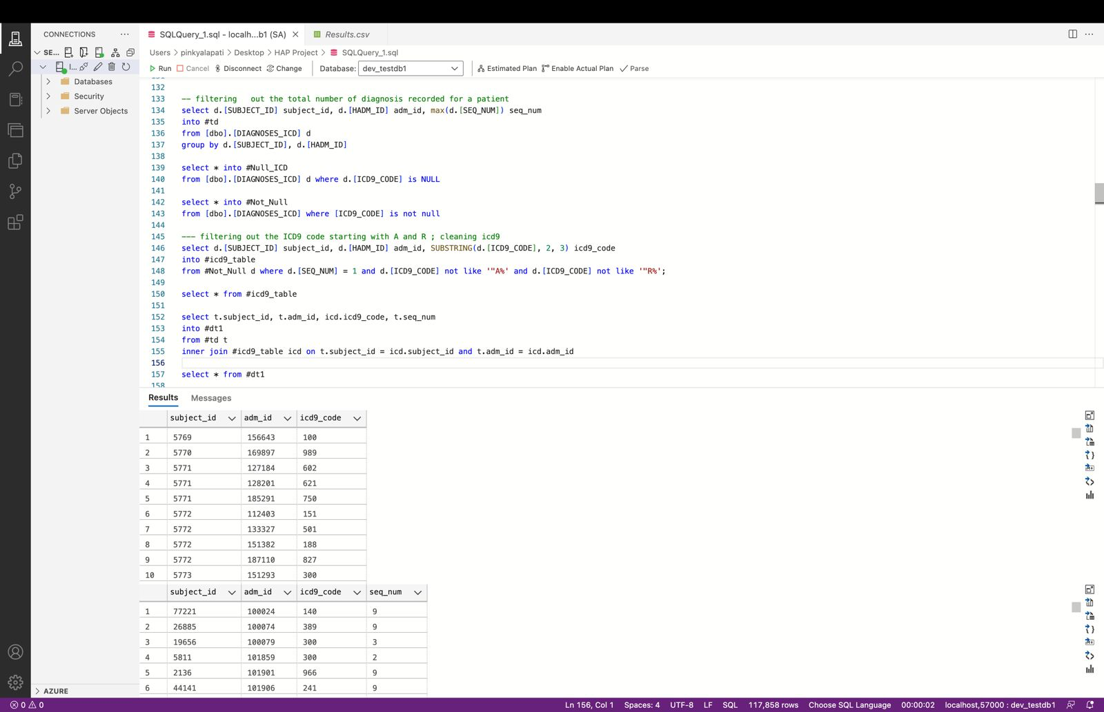

From the above screenshot we can tell that we have considered the table with ICD codes where we have removed the code that starts with ‘A’ and ‘R’ as they are no use in our analysis.

1. PROCEDURES Table:

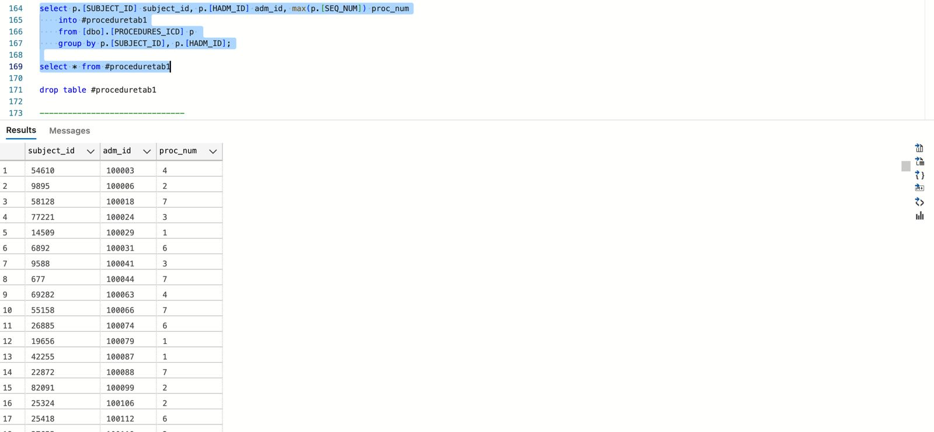

In the above figure we can see that we have calculated the total count of the procedures that patient has gone through as this plays a vital role in the determination of the length of the stay.

1. CPT EVENTS Table:

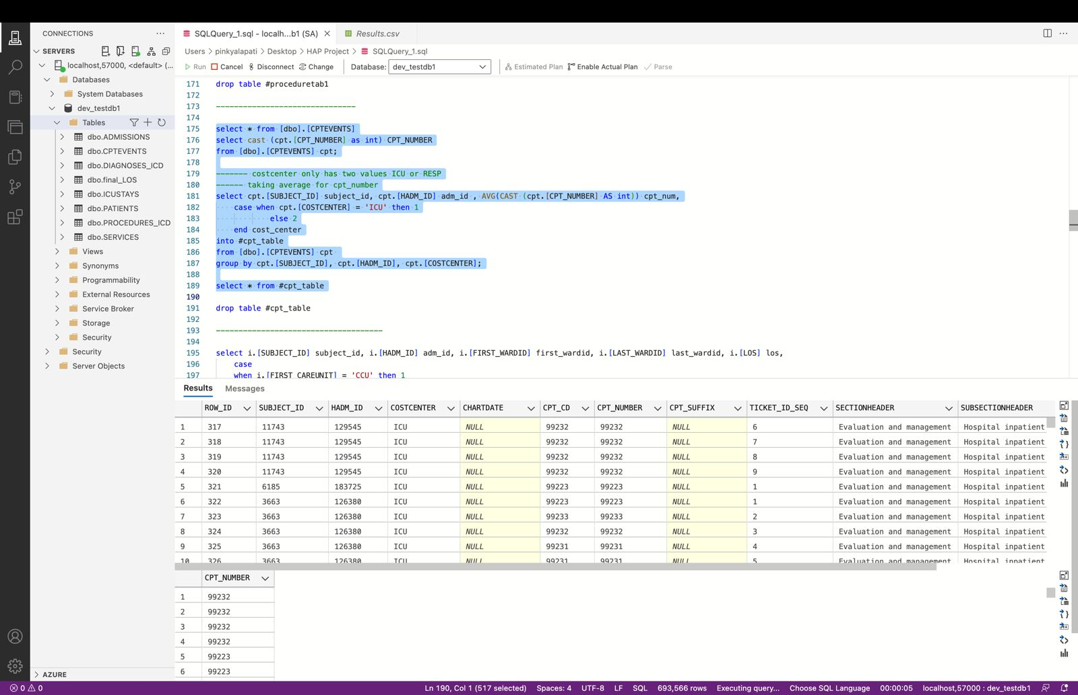

As can be seen in the above image, I used the CPT Events Table to determine the Mean value. Since there are only two values for the Cost Center, I assigned 1 to the ICU and 2 (RESP) to the other value.

1. ICU STAYS Table:

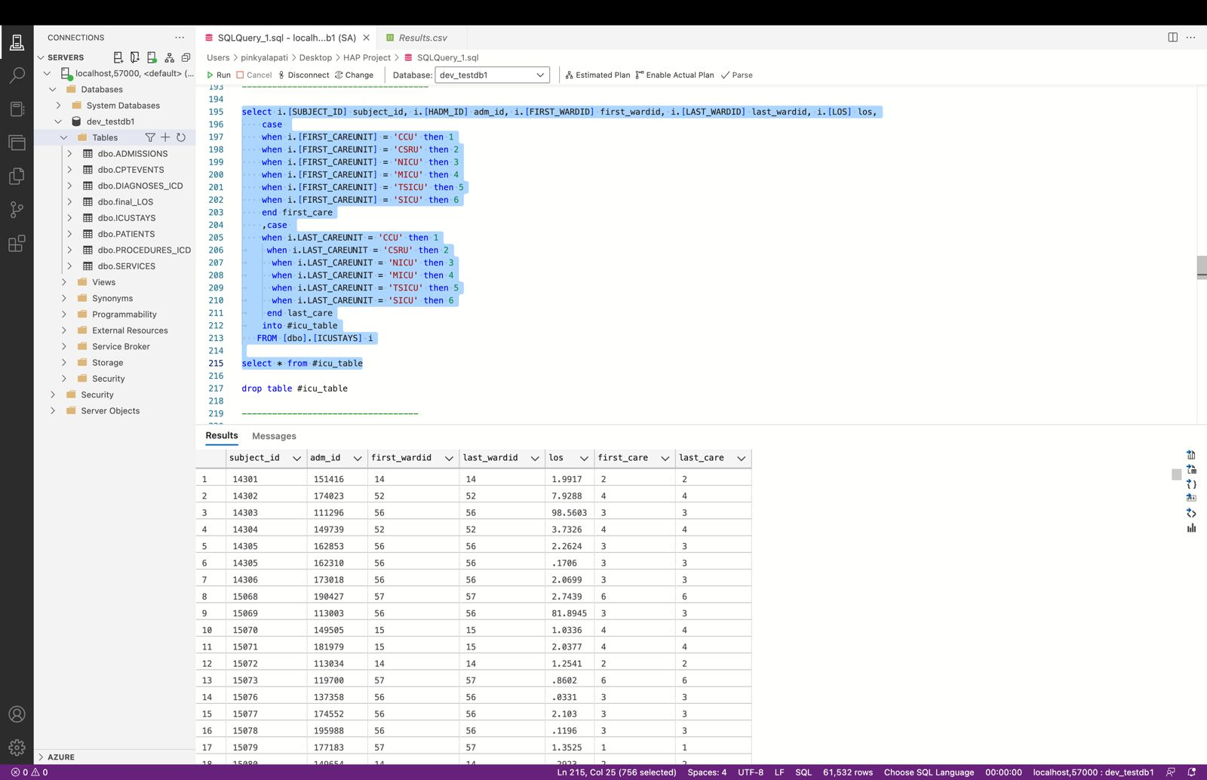

Here, in this we considered firstcareunit, lastcareunit, and length of stay and converted them into numerical value.

1. SERVICE Table:

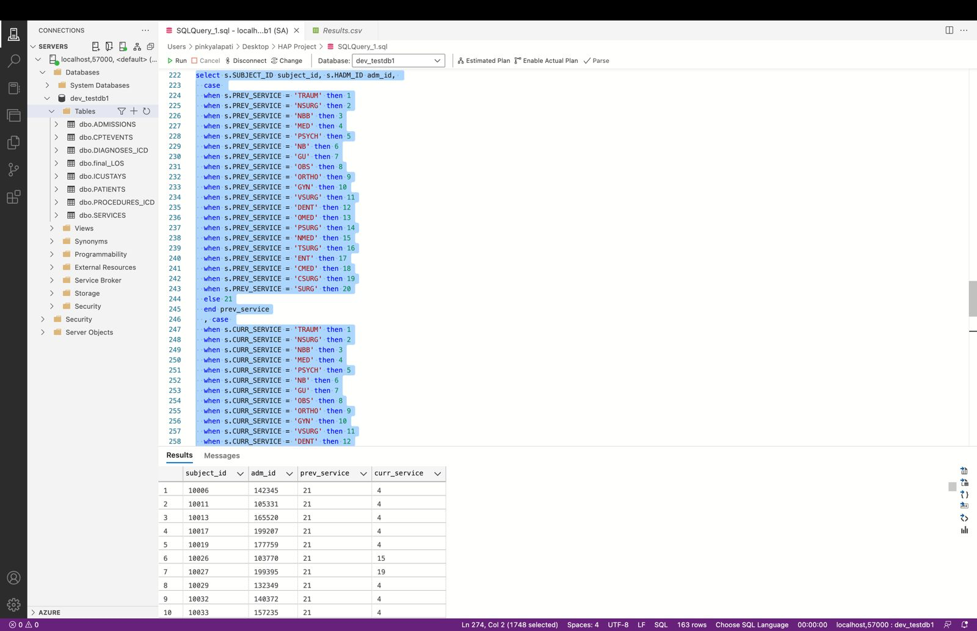

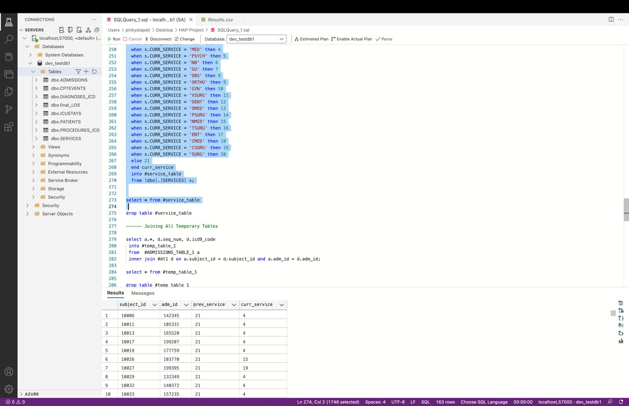

Here, we converted different services like Gyno, ORTHO etc., with a unique numerical value.

1. Joining All the Temporary Tables:

In this we have joined all the temporary tables into a single table which will be used for the final analysis in the WEKA.

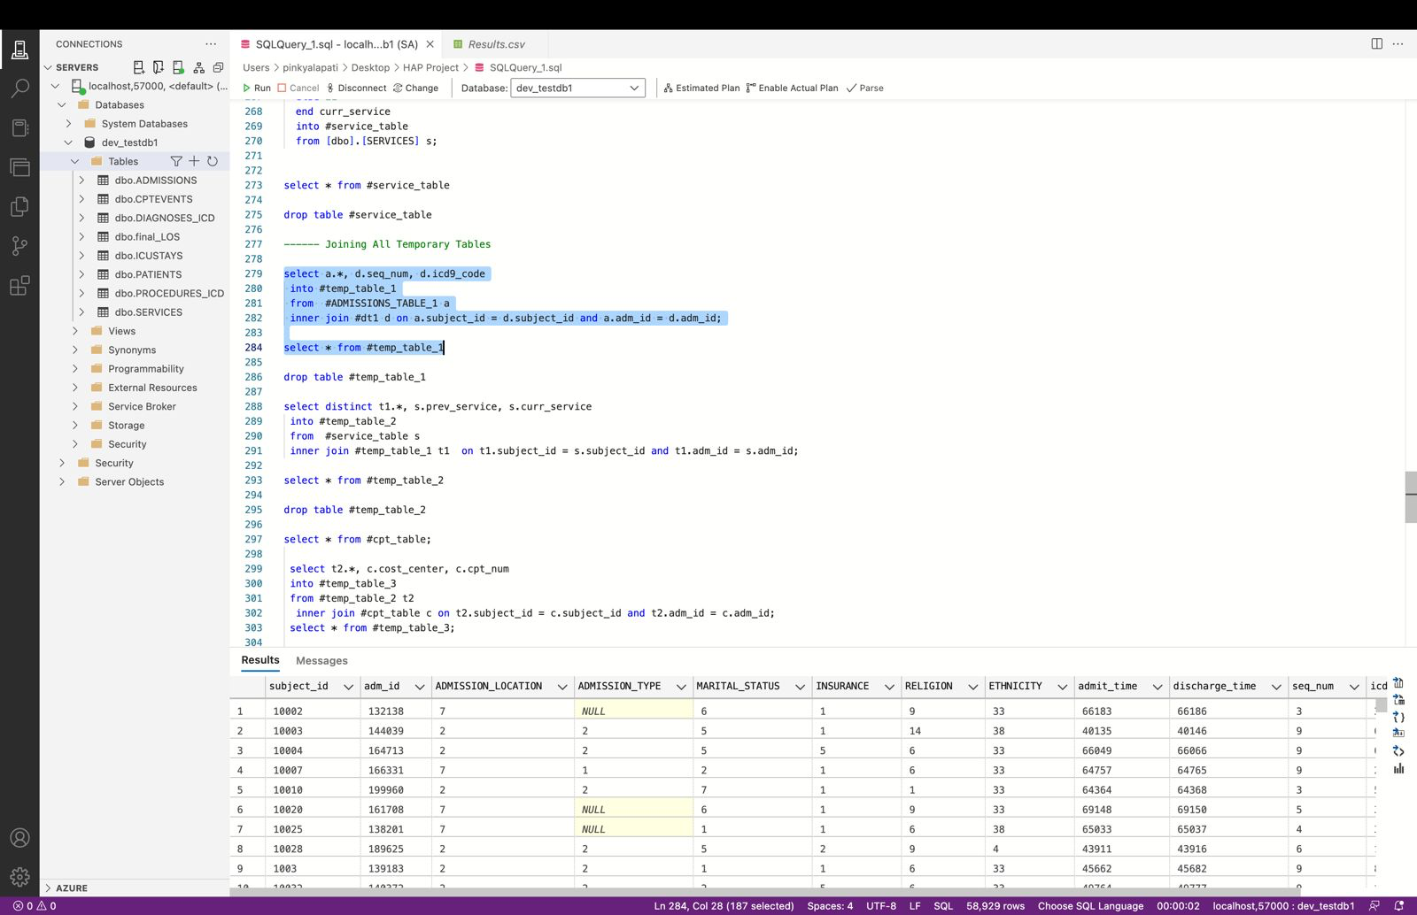

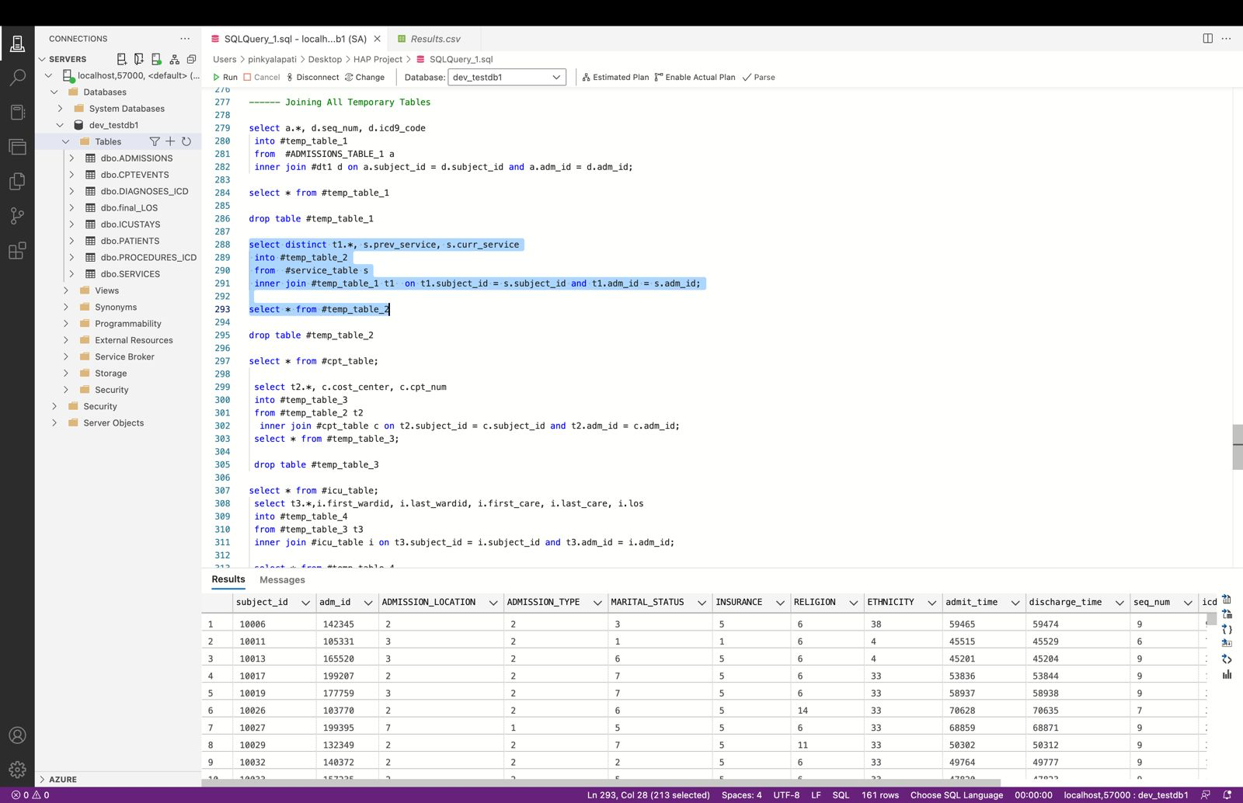

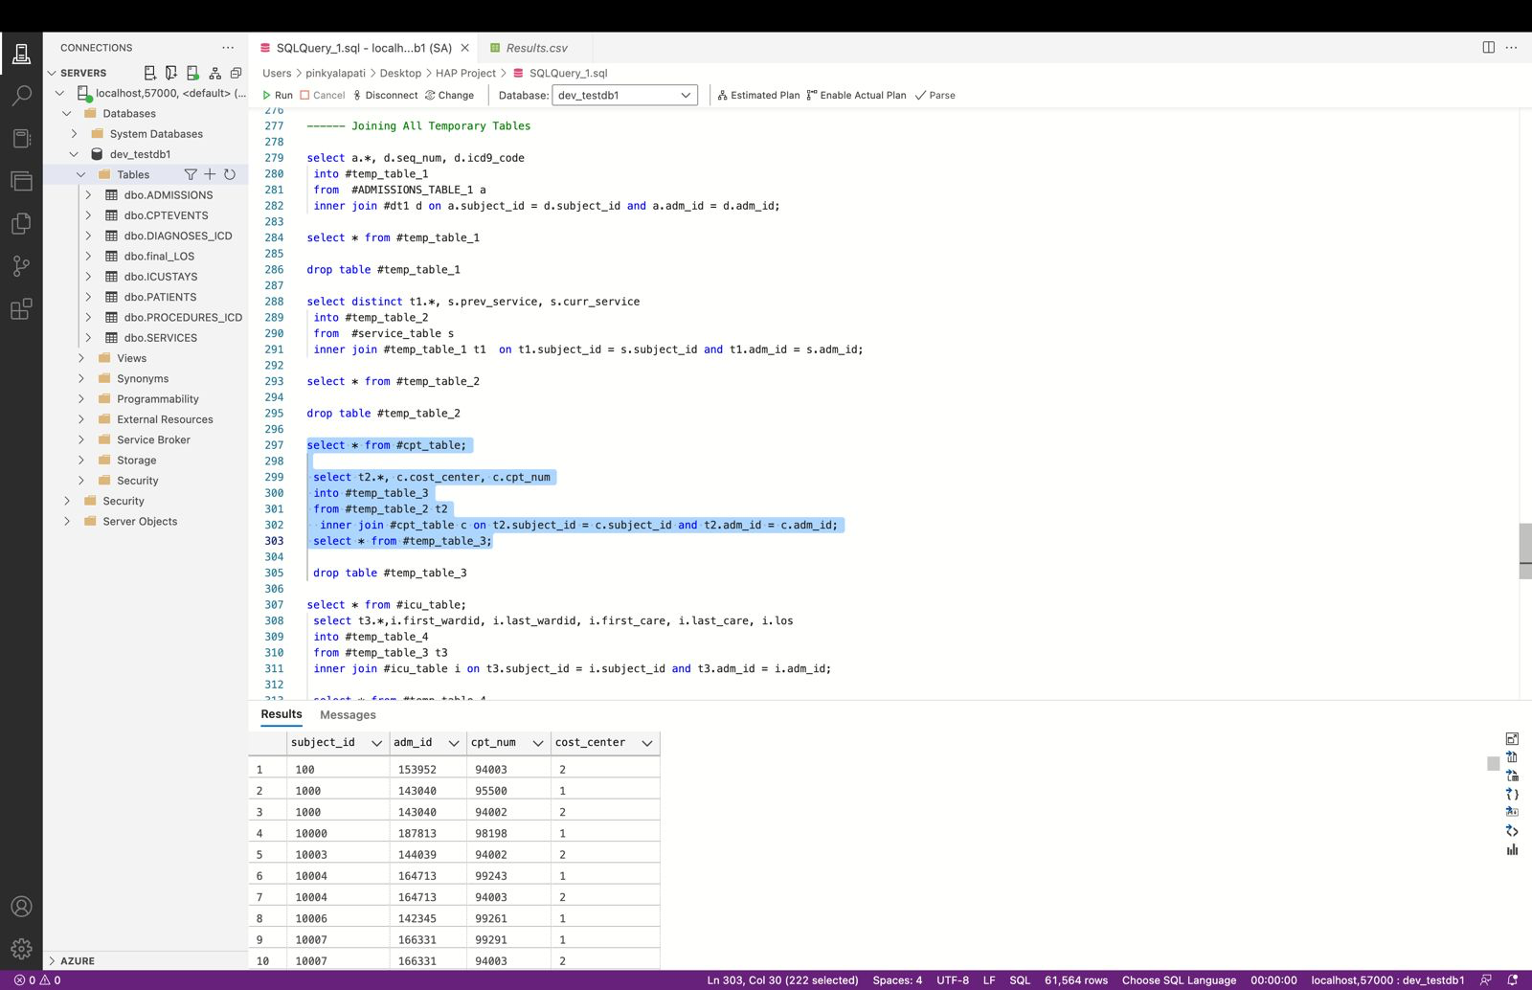

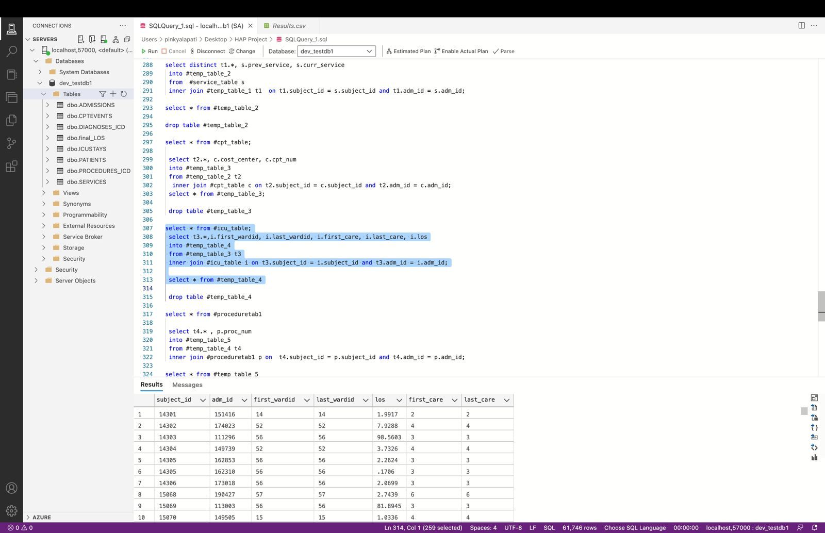

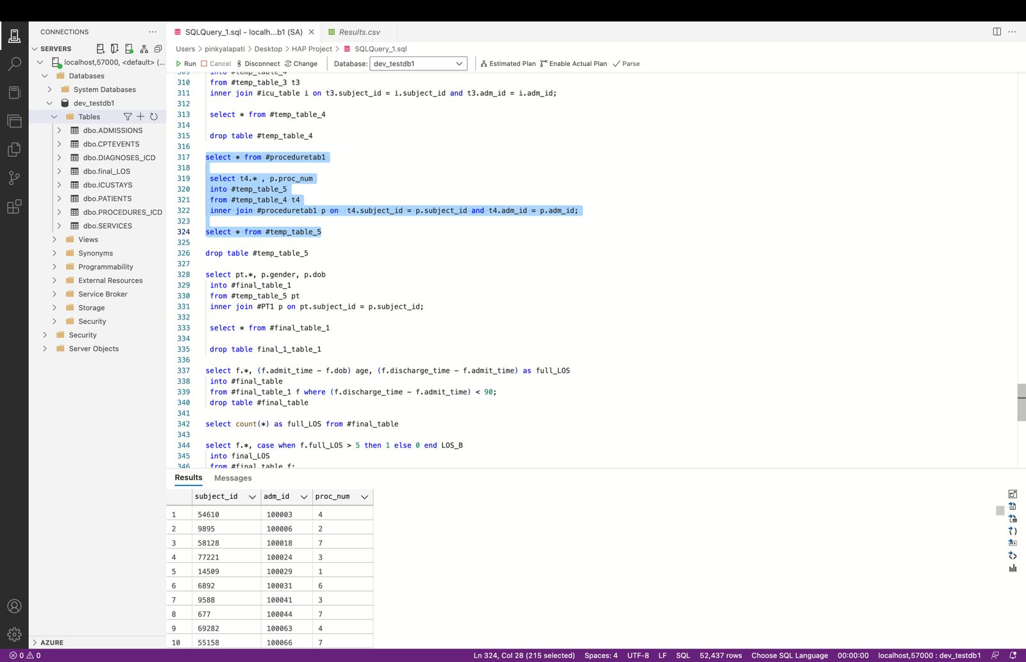

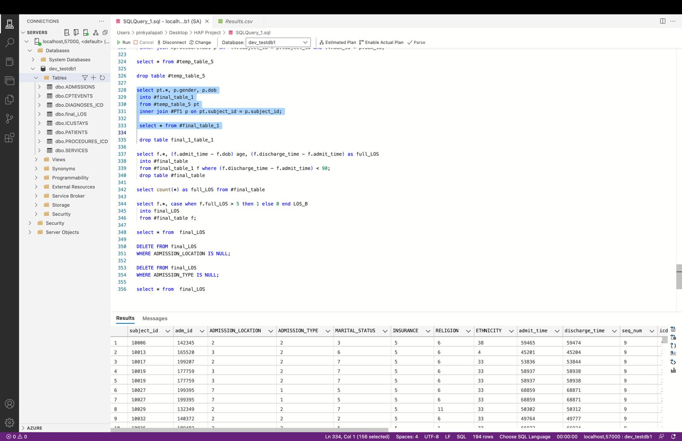

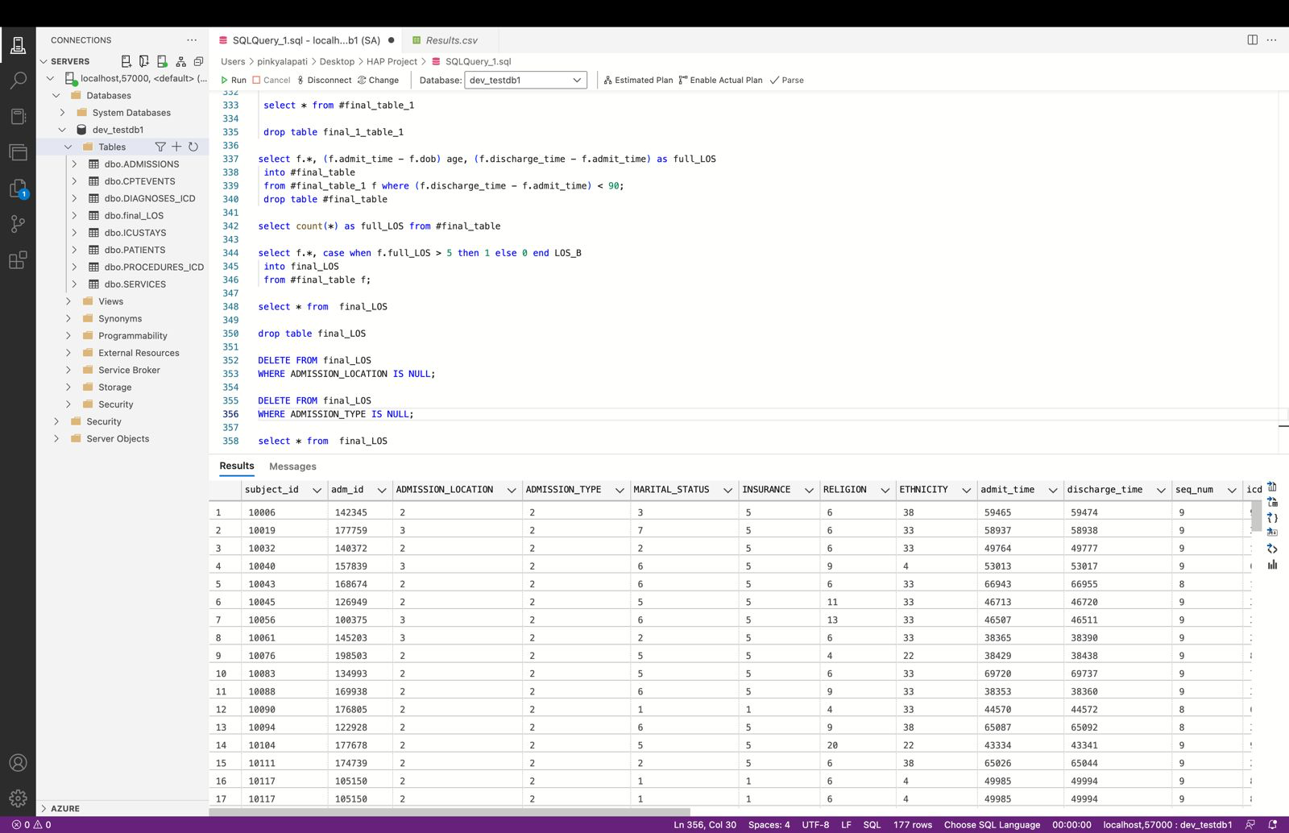

**Model Building and Outcome Prediction Using Weka:**

**Loading Data into Weka:**

* Well-formatted data from data processing steps is fed into the Weka application for further pre-processing.
* Attributes are converted into nominal data types for further operations.

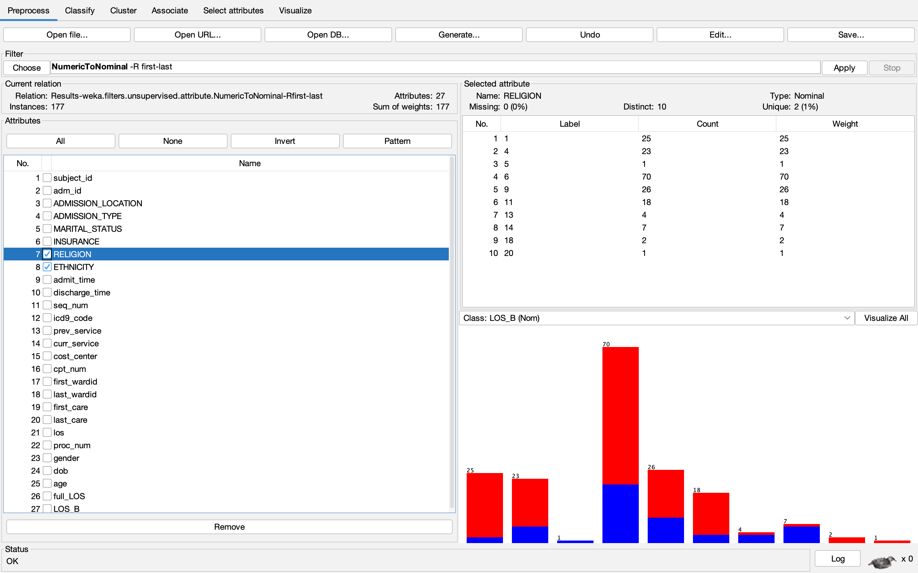

**Feature Selection:**

The use of a ranking function to prioritize attributes based on their importance in predicting LOS_B (Length of Stay Beyond a week). Initially, there was an inclination to select the top 10 variables for model development. However, it became apparent that such a limited approach might overfit the model, meaning the model would perform exceedingly well on training data but poorly on new, unseen data due to its narrow focus. To avoid this and ensure robustness, the decision was made to incorporate all 22 variables identified as significant. This comprehensive inclusion supports a more accurate and generalizable prediction of the length of stay.

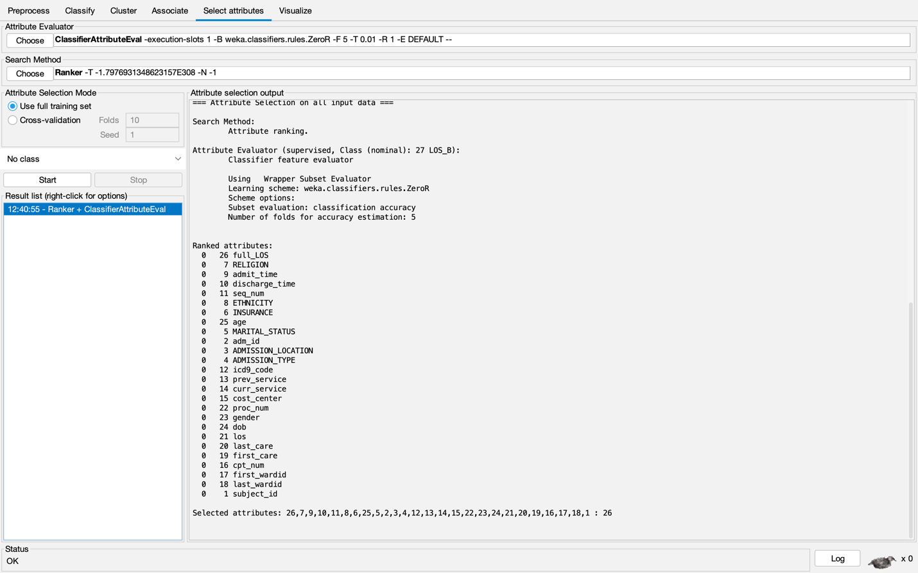

* We have removed unnecessary attributes like: subject_id, adm_id, dob, los, and full_los.
* The final number of attributes is reduced to 22.
* LOS_B is my final target variable that consists of 1’s and 0’s.

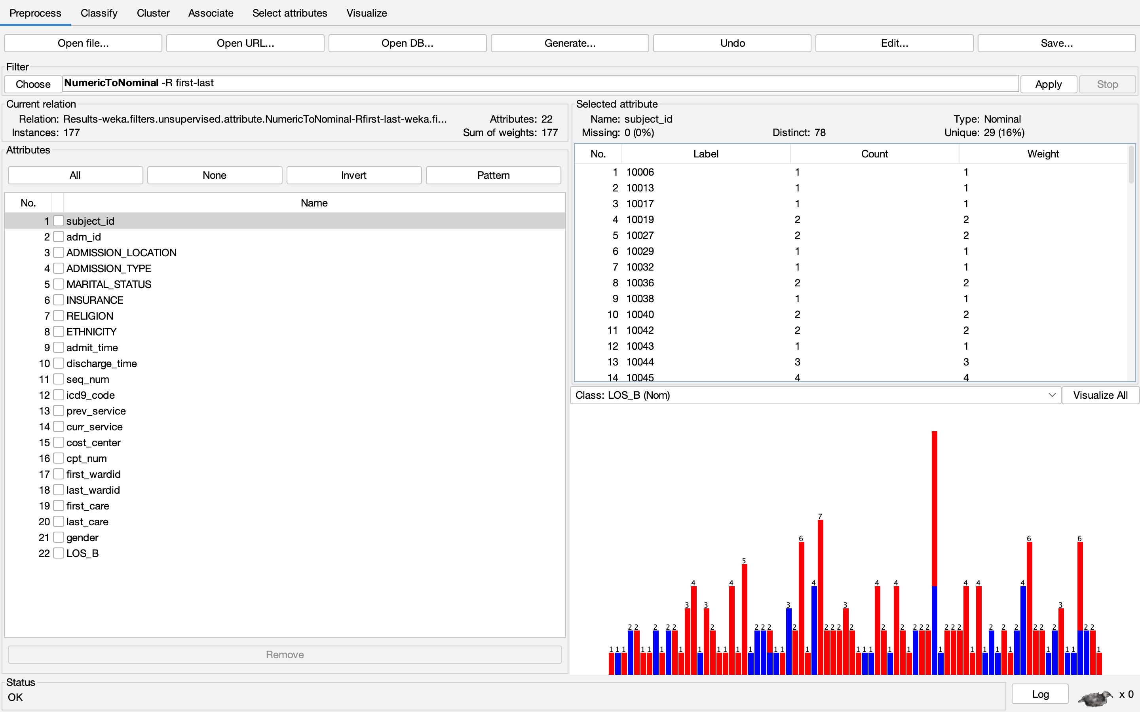

**Models:**

We have used 4 machine learning models for the prediction of LOS_B.

* Decision Tree Classifier
* Naïve Bayes Classifier
* Bayes Network Classifier
* Additive Logistic Regression

We have used 2 methods:

**Split Ratio and Validation Methods:**

* 60 – 40 Split (60% Training and 40 % Testing)
* 10-Fold Cross Validation

**Machine Learning Method Data split 60%-40%:**

Naïve Bayes Classifier:

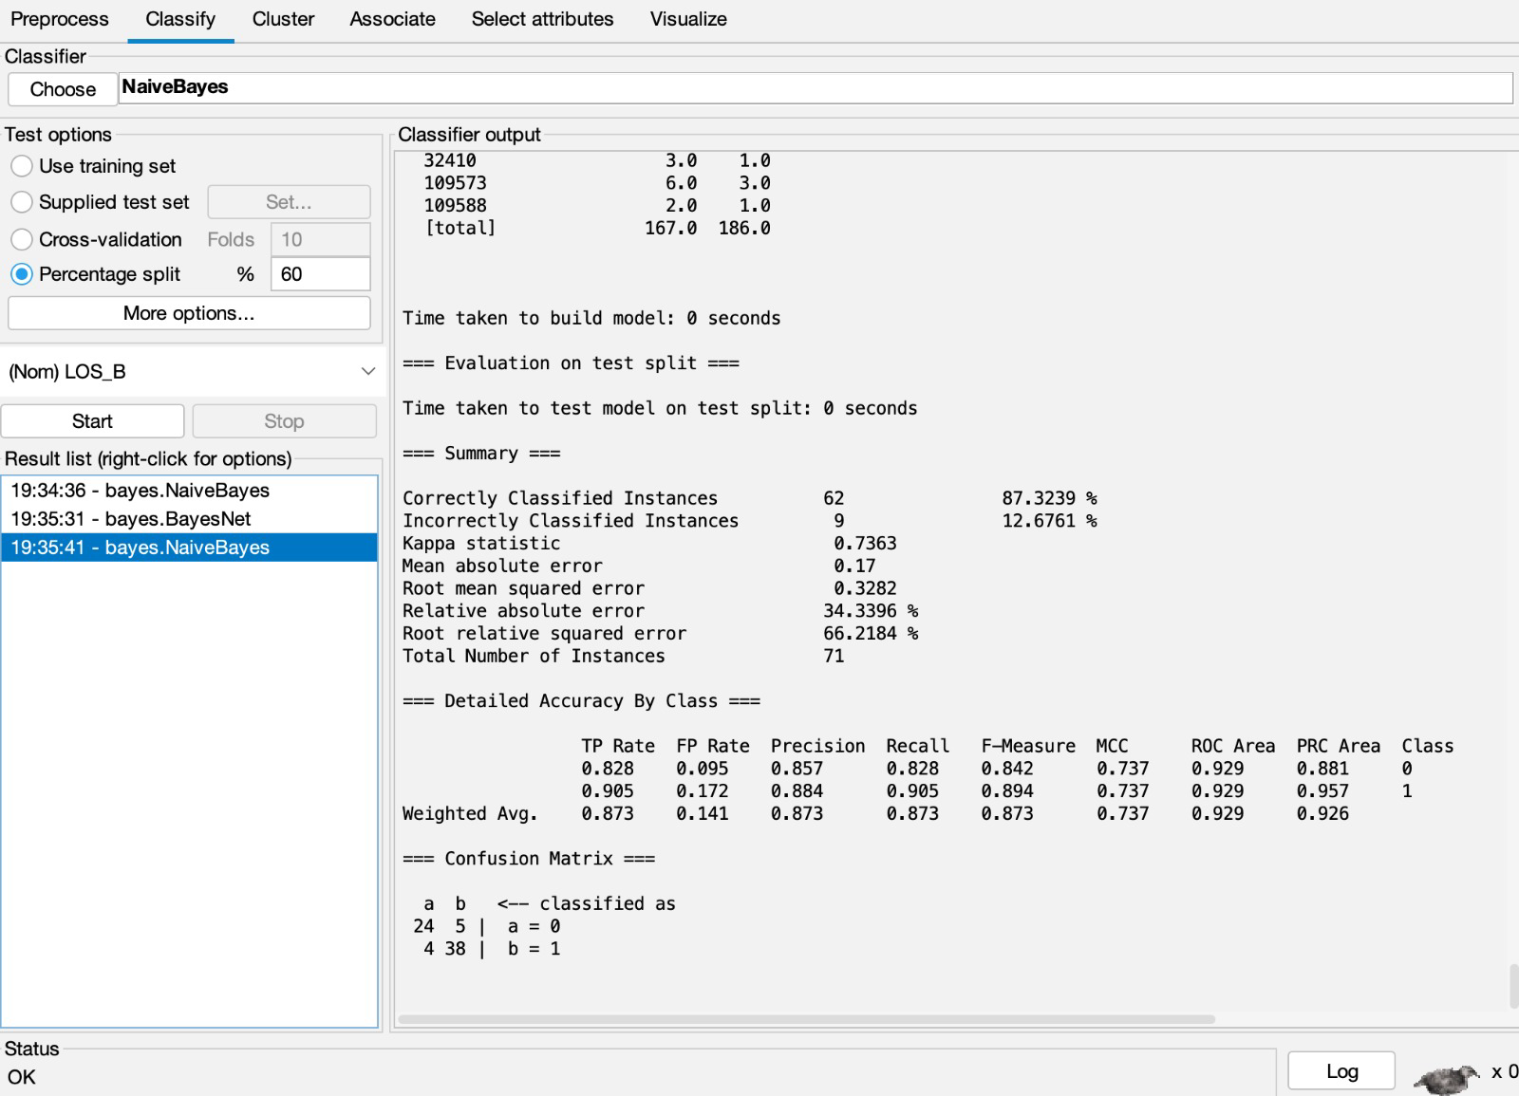

Bayes Net Classifier:

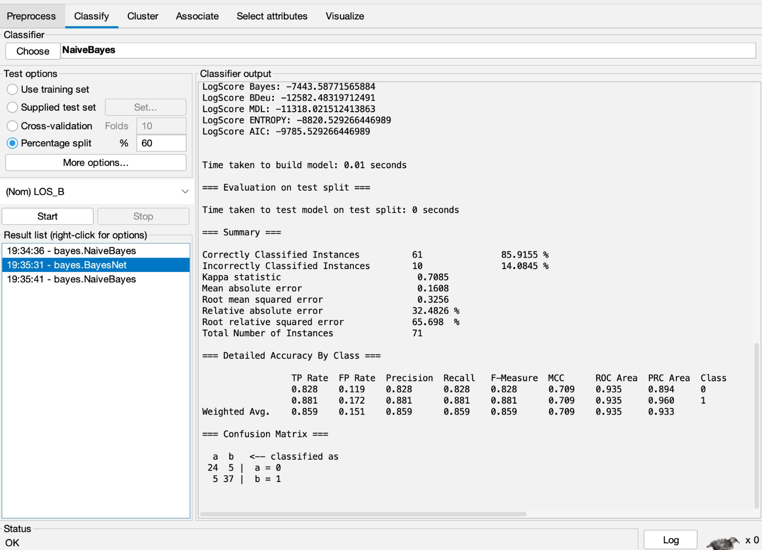

Decision Tree:

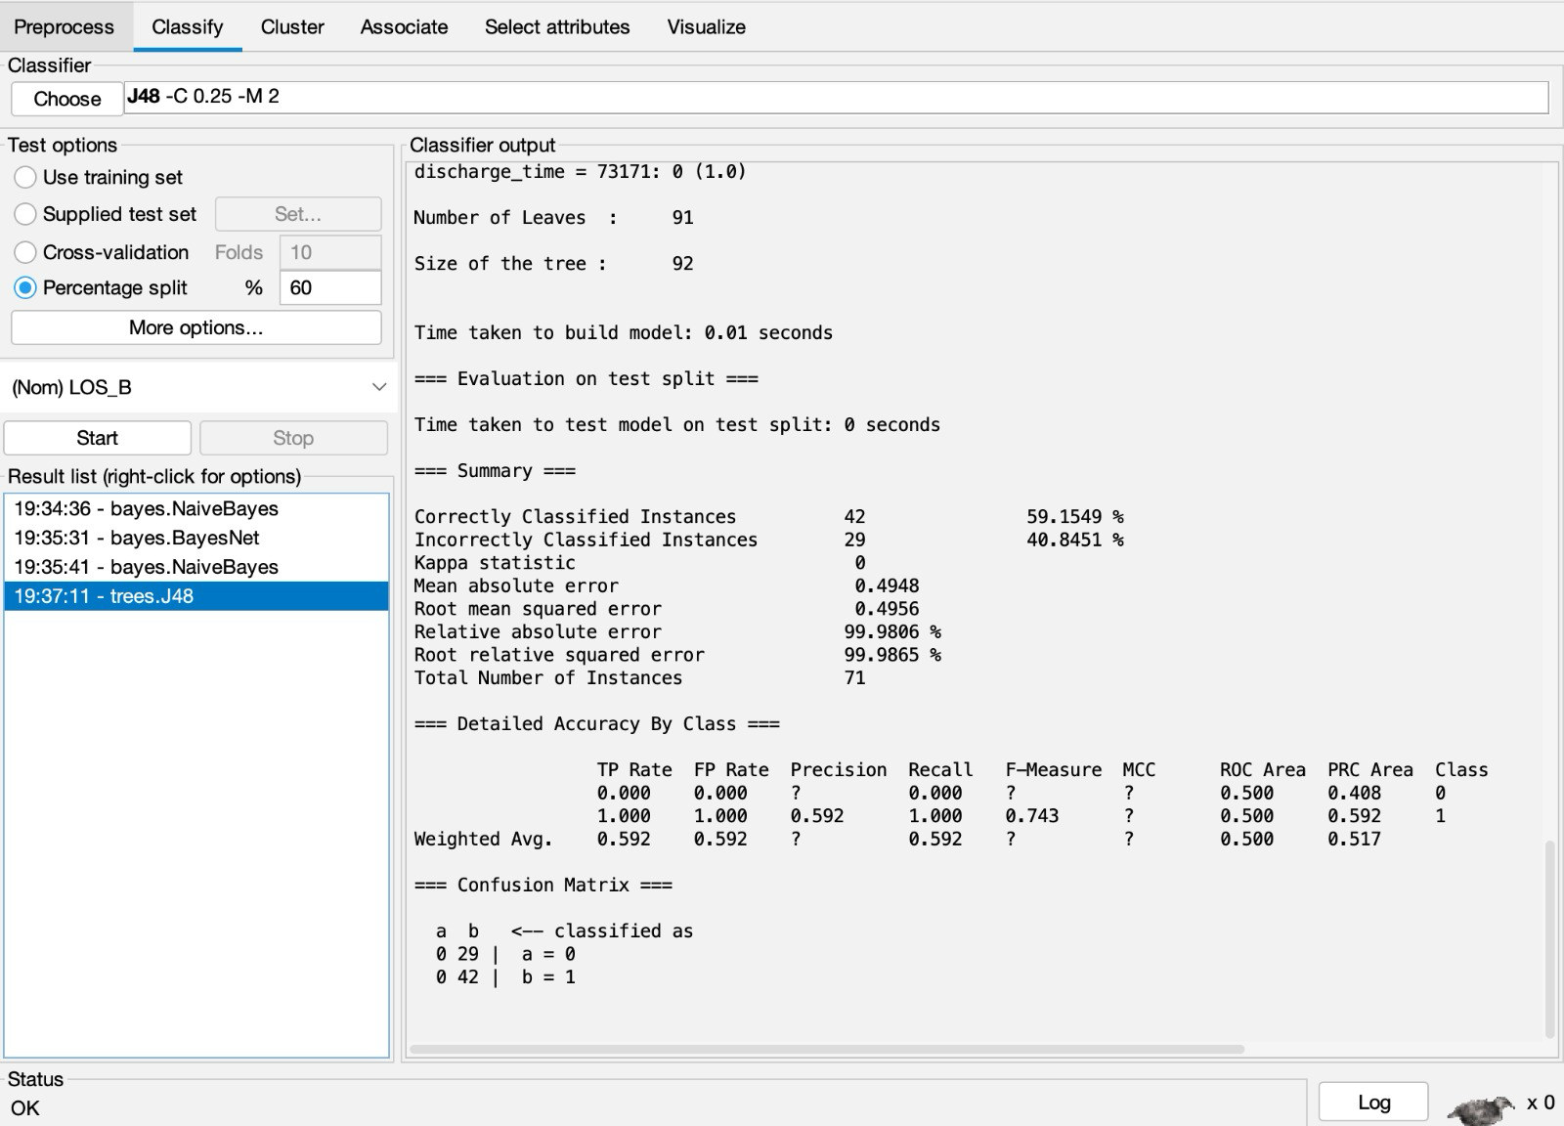

Logistic Regression:

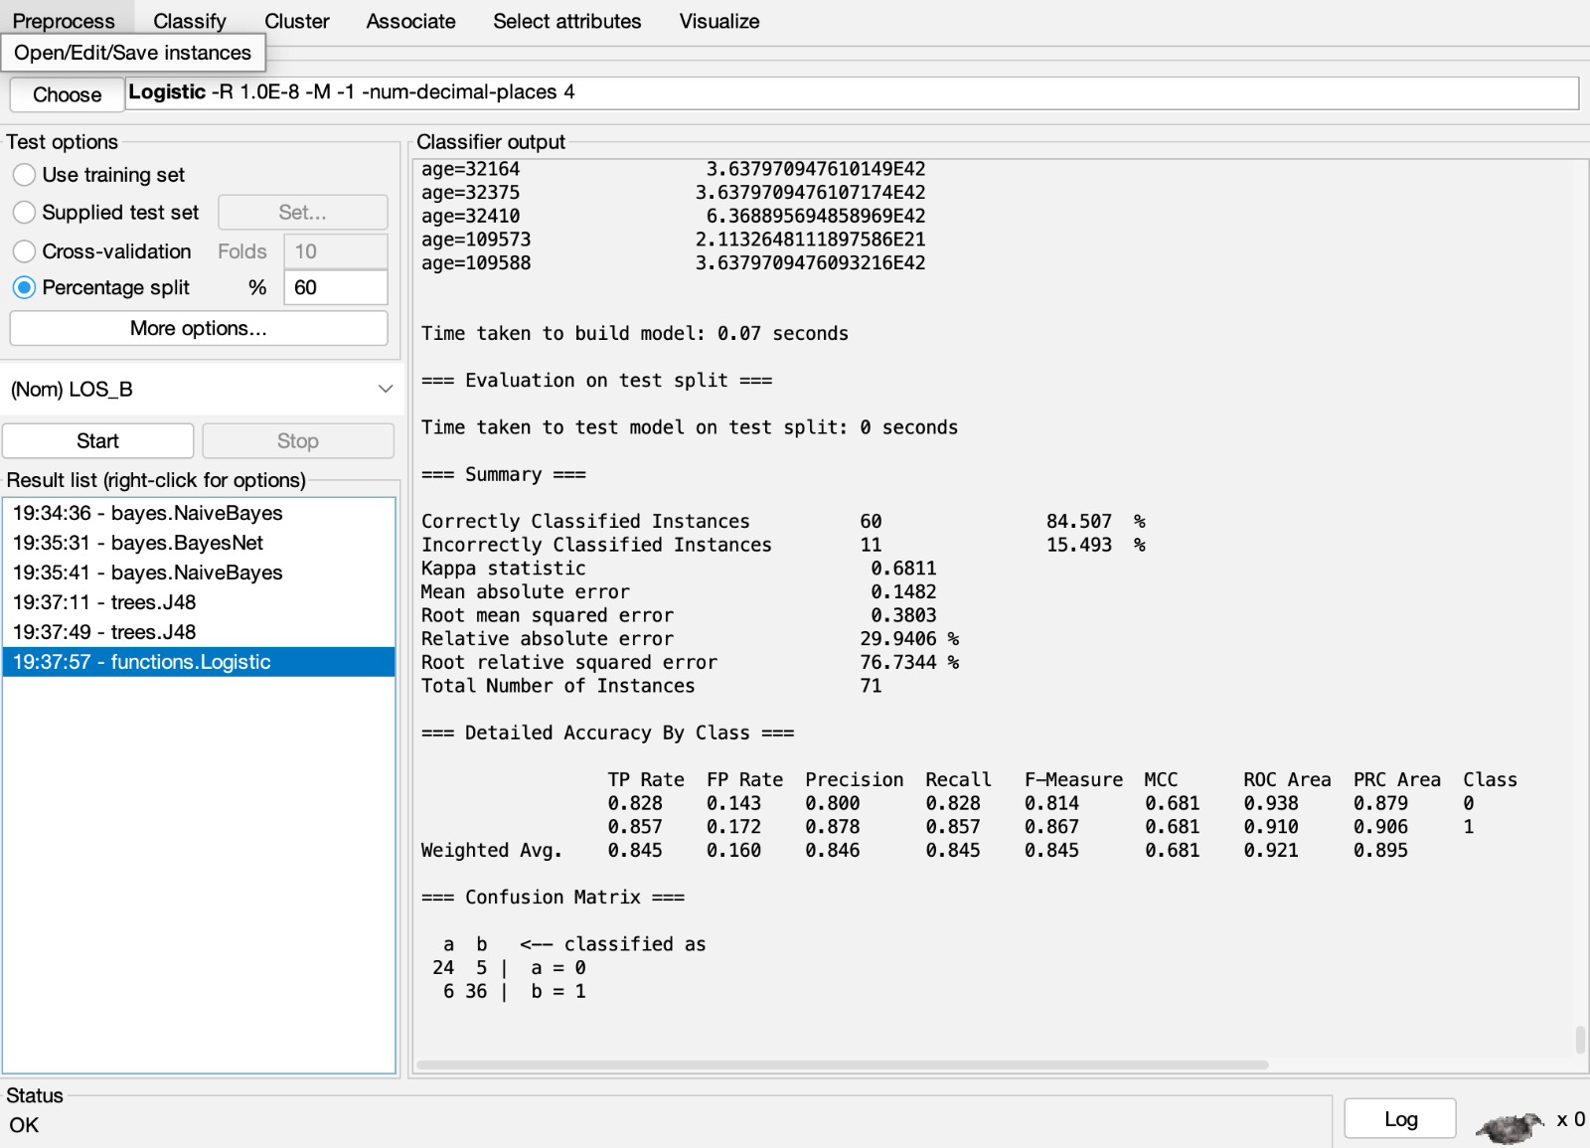

**Cross Validation with 10 folds:**

**Naïve Bayes:**

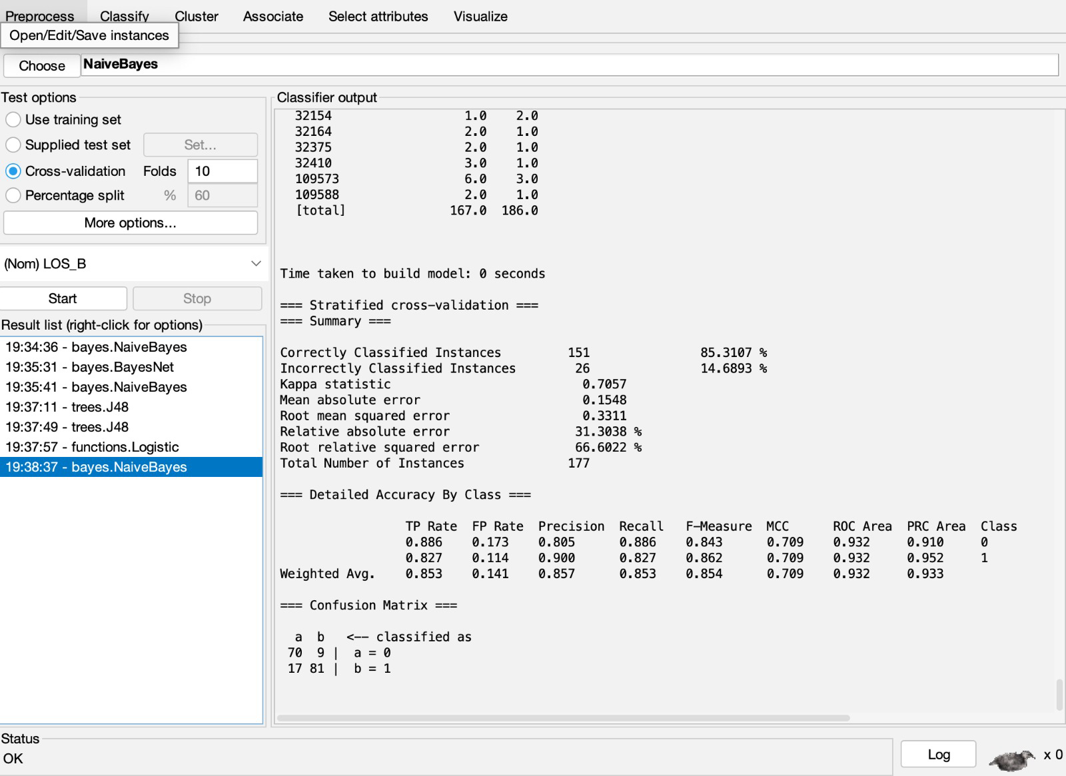

**Bayes Net:**

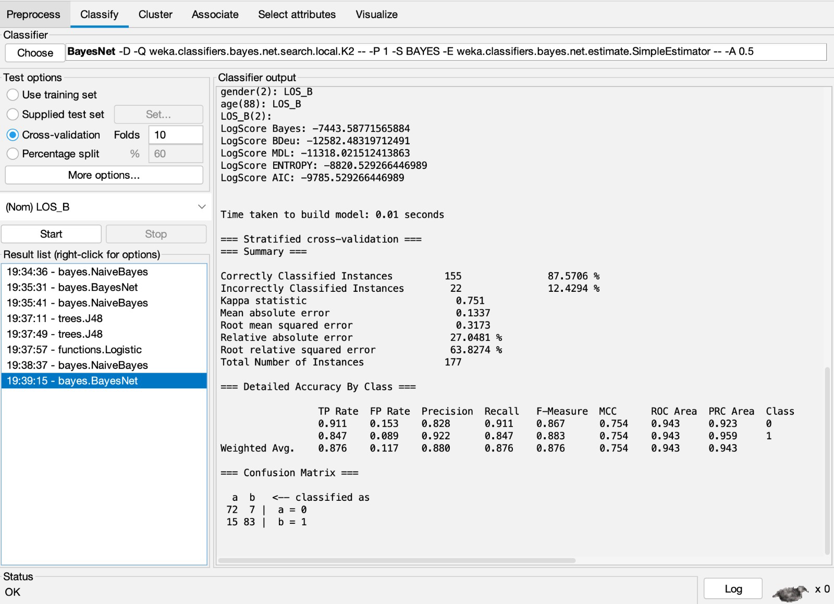

**Decision Tree:**

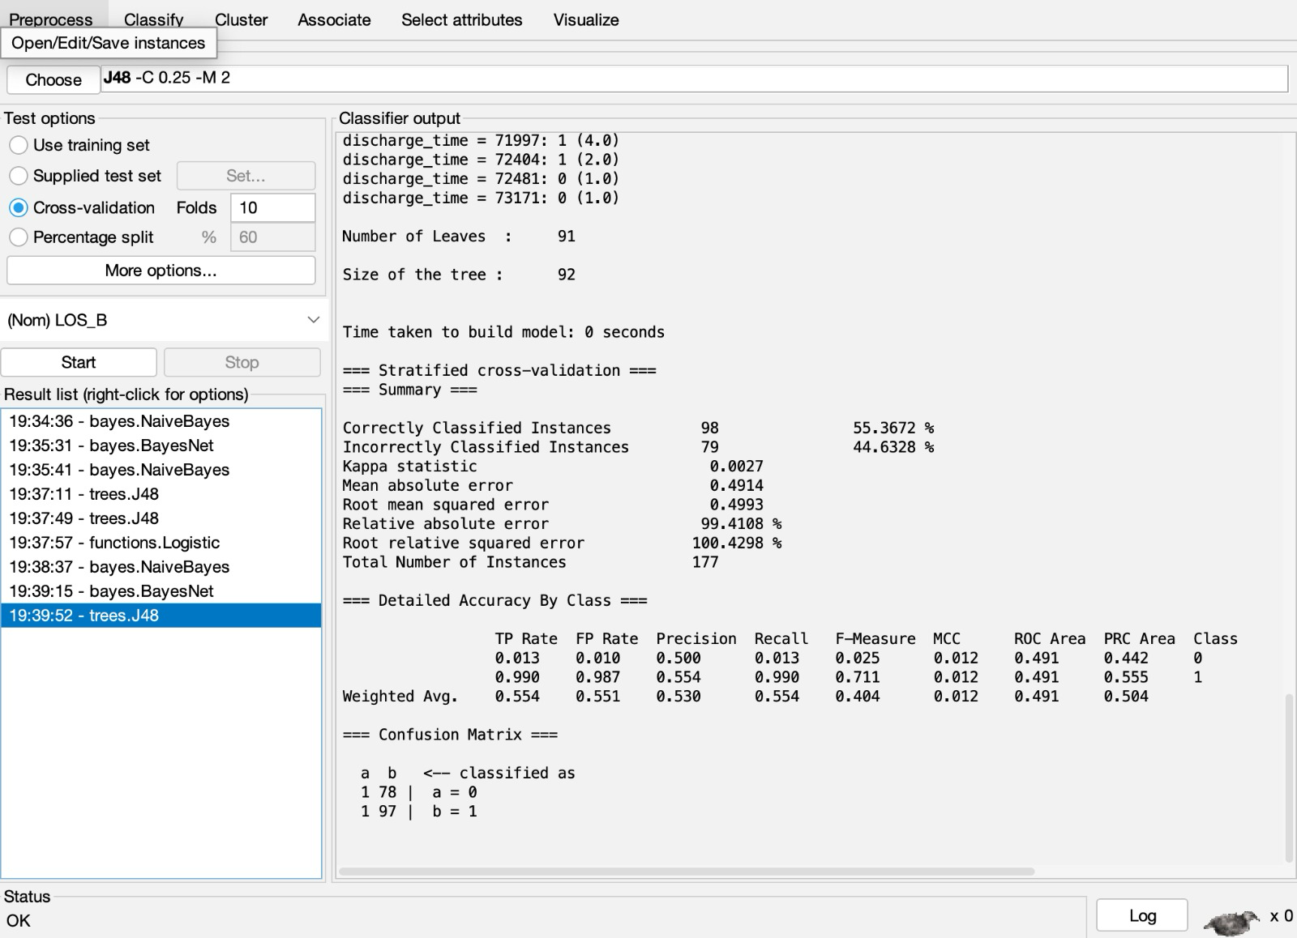

**Logistic Regression:**



**RESULTS:**

**Train Test Split: (60-40):**

|  |  |
| --- | --- |
| **Accuracy** | **Recall** |
| **87.3%** | **87.3%** |
| **85.9%** | **85.9%** |
| **84.5%** | **84.5%** |
| **59.1%** | **59.2%** |

**10- fold Cross Validation:**

|  |  |
| --- | --- |
| **Accuracy** | **Recall** |
| **85.3%** | **85.3%** |
| **87.5%** | **87.6%** |
| **89.2%** | **89.3%** |
| **55.3%** | **55.4%** |

When we compare the results of Conventional Split data and 10-fold cross-validation we can see the best results are achieved in the cross-validation although the difference is not huge there is a difference of some percent of overall change in accuracy.

**Conclusion:**

Upon reviewing the performance metrics, it becomes evident that the Naïve Bayes Network model exhibits superior accuracy. However, a closer examination of the recall metric reveals that the logistic regression model outperforms the others. Given the context of this project, where recall is of importance due to the potential consequences of resulting in false negatives, we would vote for the adoption of logistic regression. In scenarios like these where the cost of a false negative is significant, such as in medical predictions, recall becomes a critical factor, potential outweighing the overall accuracy in predicting the length of stay of a patient greater than a week.